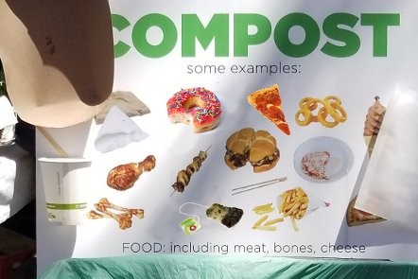
Participate in sustainability!

The Town of Boxborough is currently participating in local composting at the Town transfer station.

Residents can help divert food waste for composting which is beneficial in many ways for future regenerative waste management.

Boxborough is working together with Black Earth Compost Company to help keep valuable compost items out of the landfills by putting them back into the environment.

Its simple, easy and turns compost into valuable nutrient compost that is reused by many farmers and homeowners’ all over Massachusetts.

Look for the new green bins located in front of the trash compactors. You may line your home containers with paper grocery bags or certified compostable bag liners which all can go into the bin.

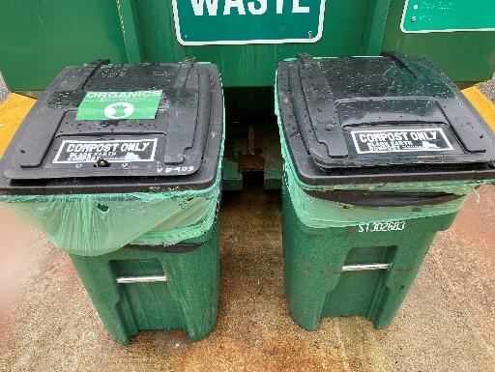
Accepted Food Waste
COFFEE GROUNDS & FILTERS ● BPI, CMA, OK Compost CERTIFIED COFFEE PODS* ● NONSYNTHETIC TEA BAGS (okay to incl. staple) ● EGGS & EGGSHELLS ● MEAT & SEAFOOD (incl. bones, shells, & raw) ● LOBSTER SHELLS (makes the compost rich) ● FRUITS & VEGGIES (incl. stems, skins, pits, seeds, corn cobs, fruit from trees) (stickers removed) ● DAIRY (cheese, yogurt, etc.) ● PASTA, GRAINS & BREAD ● COOKIES, CAKE & CANDY ● NUT & COCONUT SHELLS ● COOKING OIL & GREASE

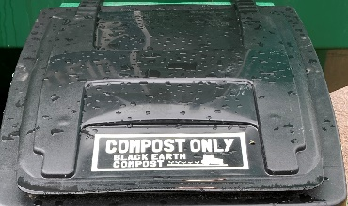
For any questions please contact the DPW Office 978-264-1790

Transfer Station 978-263-3578
Wed 11:00am-7:00pm Sat 8:00am-4:00pm

